ISLAMIC UNIVERSITY OF TECHNOLOGY

WIRELESS COMMUNICATIONS & NETWORKS LAB
CSE 4616

Lab 04
802.11 MAC Channel Access: Backoff Strategy Evaluation

Author:
Rahatut Tahrim Mounota (220041122)
September 2026
Simulation Environment: OMNeT++ 6.0 with INET Framework v4.5 (IEEE 802.11 DCF)

Introduction
IEEE 802.11 Distributed Coordination Function (DCF) uses a backoff mechanism to coordinate access to a shared wireless channel among competing stations. The choice of backoff strategy affects collision probability, packet delivery, retransmissions, and overall channel performance, particularly as the number of contending stations increases.
This laboratory study evaluates five MAC-layer backoff strategies under increasing network contention: common backoff with collision-based doubling, incremental deterministic initial backoff, persistent random backoff, deterministic backoff with collision randomization, and adaptive contention-window control. All strategies are evaluated using the same topology, traffic pattern, PHY configuration, and simulation duration so that the primary experimental difference is the MAC backoff mechanism.
The experiments are conducted using OMNeT++ 6.0 with the INET Framework v4.5. Six wireless-node configurations are considered: 3, 5, 10, 20, 50, and 100 stations. Performance is evaluated using throughput, Packet Delivery Ratio (PDR), collision probability, and retransmission count. The collected simulation statistics are used to examine how the different backoff strategies behave as network contention increases.
The report also describes the implementation of the five strategies, their relationship to the standard IEEE 802.11 DCF procedure, and the limitations of the available simulation data. Metrics such as delay, fairness, contention-window behavior, traffic-load sensitivity, and statistical variation are discussed as areas requiring additional simulation data.

Objective
The objective of this laboratory study is to evaluate and compare five MAC-layer channel-access strategies in an IEEE 802.11 DCF wireless network as the number of contending stations increases from 3 to 100. The evaluated strategies are:
- Common backoff with collision-based doubling.
- Incremental deterministic initial backoff.
- Persistent random backoff.
- Deterministic backoff with collision randomization.
- Adaptive contention-window control.
Each strategy is evaluated using throughput, PDR, collision probability, and retransmission count. The experiments use identical network, traffic, PHY, and timing configurations across all strategies. The resulting OMNeT++/INET simulation statistics are analyzed to determine how each backoff mechanism affects MAC-layer performance under increasing network contention.

1. Network Topology and Simulation Setup

1.1 Topology
The baseline topology follows the laboratory specification, beginning with 3 wireless stations and scaling up to 100 stations. The wireless stations share a common IEEE 802.11 DCF channel and are accompanied by 3 wired nodes on the wired side. For the MAC-layer backoff experiments, the wireless stations form the primary contention domain because they compete for access to the shared wireless medium.
Each wireless station generates one 100 B UDP packet per second during the 2-second simulation interval, resulting in two generated packets per station in each simulation run. The network topology, radio configuration, traffic generation pattern, packet size, and simulation duration are kept consistent across all five tasks. Only the MAC-layer backoff mechanism is changed between experimental configurations.

1.2 Simulation Parameters
Table 1. Common OMNeT++ / INET simulation parameters
Parameter | Value | Simulation Configuration
Simulation Framework | OMNeT++ 6.0 + INET 4.5 | Simulation environment
MAC | IEEE 802.11 DCF | MAC configuration
Wireless Nodes | 3, 5, 10, 20, 50, 100 | Experimental variable
Wired Nodes | 3 | Network topology
Bitrate | 2 Mbps | PHY configuration
Transmission Power | 20 mW | Radio configuration
Receiver Sensitivity | -85 dBm | Radio configuration
SNIR Threshold | 4 dB | Radio configuration
Bandwidth | 22 MHz | Wireless channel configuration
Background Noise | -110 dBm | Wireless channel configuration
Packet Size | 100 B | Application configuration
Packet Interval | 1 s | Application configuration
Packets per Node | 2 packets per run | Application configuration
Simulation Time | 2 s | Simulation configuration
Initial CW | 15 | MAC configuration
The common configuration follows the parameters specified by the laboratory exercise, which requires the topology, radio parameters, traffic parameters, and simulation duration to remain consistent when comparing the different algorithms.

1.3 Experimental Execution and Data Collection
The experiments were conducted using OMNeT++ 6.0 with the INET Framework v4.5. A total of 30 simulation configurations were evaluated, corresponding to five MAC backoff strategies and six wireless-node densities: 3, 5, 10, 20, 50, and 100 stations.
For each configuration, the corresponding MAC backoff implementation was compiled and executed within the OMNeT++/INET simulation environment. The same topology, PHY parameters, packet size, traffic generation interval, contention-window limits, retry settings, and simulation duration were maintained across the experiments.
During each simulation run, relevant INET statistics were collected, including packet generation, packet reception, received packet bytes, transmission attempts, collision events, and retransmissions. The resulting simulation records were processed to calculate throughput, Packet Delivery Ratio, collision probability, and retransmission count.
The performance measurements presented in the results section are therefore based on the corresponding OMNeT++/INET simulation runs and their recorded simulation statistics.

2. Original IEEE 802.11 DCF Backoff Mechanism

2.1 Channel-Access Procedure
IEEE 802.11 Distributed Coordination Function uses Carrier Sense Multiple Access with Collision Avoidance to coordinate access to a shared wireless medium.
The basic channel-access procedure is as follows:
- A station senses the wireless channel.
- If the channel is busy, the station waits until the channel becomes idle.
- After the channel becomes idle, the station waits for the required inter-frame spacing.
- The station selects a backoff value from the current contention window.
- The backoff counter decreases while the channel remains idle.
- If another transmission is detected, the backoff counter is frozen.
- When the counter reaches zero, the station attempts transmission.
- A successful transmission is acknowledged by the receiver.
- If a collision occurs or an acknowledgement is not received, the station performs collision recovery according to the configured backoff strategy.
- The contention window may be increased following a collision and reset or modified following a successful transmission.
The contention window determines the range from which the station selects its backoff value. The backoff mechanism is important because it determines how competing stations distribute their transmission attempts over available channel-access opportunities.

2.2 Backoff and Contention-Window Formulas
The standard IEEE 802.11 collision-response mechanism uses binary exponential backoff. When a collision occurs, the contention window is increased, subject to the configured maximum value. Increasing the contention window provides a larger range of possible backoff values and reduces the likelihood that multiple stations repeatedly select the same transmission opportunity.
After a successful transmission, the contention window is normally reset toward the minimum contention-window value according to the MAC implementation. The alternative strategies evaluated in this laboratory modify the initial backoff selection, persistence of backoff values, collision-recovery behavior, or contention-window adaptation while keeping the common network topology and traffic configuration unchanged.
The backoff value is selected randomly from the current contention window:
B = Random(0, CW), T_{backoff} = B × T_{slot}
CW_{new} = min(2(CW_{old} + 1) − 1, CW_{max}) = min(2·CW_{old} + 1, CW_{max})
With CW_{min} = 15: 15 → 31 → 63 → 127 → 255 → 511 → 1023
When two stations independently select their backoff values uniformly from the range 0 to CW, the probability that a particular pair selects the same backoff slot in a given contention round is 1/(CW + 1). Therefore, increasing the contention window after a collision increases the number of available backoff slots and reduces the probability of repeated slot selection by a given pair of stations.

2.3 Where These Concepts Live in INET
Table 2. Backoff concepts and their INET implementation
Concept | INET implementation
Channel sensing | The receiver combines physical carrier sensing with NAV information and informs the Contention instance when the medium is available. The CSMA/CA MAC uses this information through the medium-state handling, including the isMediumFree() mechanism.
Backoff generation | The Contention component generates the backoff value through startContention(cw, …), which selects a random value using intrand(cw + 1). In the generic MAC implementation, backoff generation is handled through CsmaCaMac::generateBackoffPeriod().
Backoff timer | The IFS_AND_BACKOFF state manages the inter-frame spacing and backoff countdown. The computeRemainingBackoffSlots() function determines the remaining backoff slots and freezes the countdown when the wireless medium becomes busy.
Contention window | The DCAF and EDCF components maintain the current contention window together with the configured minimum and maximum contention-window values.
Collision / retransmission | When an acknowledgement is not received within the expected period, the frame is processed as a failed transmission through originatorProcessFailedFrame. The retry state is updated and the frame remains in the appropriate in-progress frame structure for retransmission.
CW growth and reset | The DCAF component increases the contention window through incrementCw(), using the configured maximum as the upper bound. After a successful transmission, resetCw() restores the contention window to the configured minimum value.
Retry limit | The NonQosRecoveryProcedure maintains the relevant short- and long-retry counters. When the configured retry limit is reached, the frame is discarded with a RETRY_LIMIT_REACHED condition and the corresponding link-failure indication is generated.
Successful transmission | When an acknowledgement is successfully received, the contention window is reset and the corresponding frame transmission procedure is completed.

3. Implementation methodology for each task

3.1 Backoff Rules per Task
Each task modifies the backoff behavior while keeping the common network configuration unchanged. In particular, the tasks differ in how the initial backoff is selected and how the backoff or contention-window state is updated following a collision or a successful transmission. Table 3 summarizes the backoff rules used in the five tasks, while the corresponding implementation details are described in Section 4.
Table 3. Backoff rules of the five tasks
Task | Initial backoff | After collision | After success
Task 1 | Same initial backoff for all nodes, derived from the configured contention window | Contention window is doubled, subject to the maximum limit | Contention window is reset and the common initial backoff is restored
Task 2 | Deterministic value based on node index: node i uses i + 1 | Backoff is increased according to the collision-response rule | Return to the assigned deterministic value, i + 1
Task 3 | Random base backoff selected once for each node | Contention window is increased according to the collision-response rule | Return to the persistent base backoff without generating a new base value
Task 4 | Random backoff is used for a new recovery state, followed by deterministic operation after a successful transmission | A new random backoff is selected for collision recovery | Deterministic value is set to the backoff value associated with the previous successful transmission
Task 5 | Random backoff selected from the current contention window with adaptive CW control | Contention window is increased when the observed collision rate is above the high threshold | Contention window is decreased when the observed collision rate is below the low threshold, subject to CWmin and CWmax
Task 4 variant. The deterministic value is the backoff value associated with the previous successful transmission. This corresponds to Option B specified in the laboratory manual.
Task 5 statistic. The collision rate is calculated over a sliding window of recent transmission attempts. It is obtained by dividing the number of collision events by the total number of attempts in the window. For example, for the history [1, 1, 0, 1, 0, 0, 0, 0], there are 3 collision events among 8 attempts, giving a collision rate of 0.375. When the collision rate exceeds the configured high threshold, the contention window is increased. When it falls below the configured low threshold, the contention window is decreased. The contention window remains bounded by the configured minimum and maximum values.

3.2 Contention and Collision Analysis
In an IEEE 802.11 DCF network, collision probability represents the likelihood that multiple stations transmit during the same channel-access opportunity. As the number of contending stations increases, competition for the shared wireless medium generally increases collision probability.
The results show this trend for all five strategies. From N = 3 to N = 100, collision probability increases from 0.4545 to 0.9408 for Task 1, 0.1250 to 0.6032 for Task 2, 0.2500 to 0.6988 for Task 3, 0.2500 to 0.5868 for Task 4, and 0.1429 to 0.2947 for Task 5.
The differences result from how each strategy distributes transmission opportunities. Task 1 can synchronize stations through a common backoff, while Tasks 2–4 use deterministic or randomized mechanisms to reduce repeated alignment. Task 5 additionally adapts the contention window according to observed collisions. Thus, the five strategies exhibit different collision trends as network contention increases.

4. Important code modifications

4.1 NED Network Configuration
The NED network definition establishes the common simulation topology used for the five MAC-layer experiments. The network contains the wireless stations, the wireless communication infrastructure, and the wired nodes specified by the laboratory setup.
The number of wireless stations is parameterized so that the same network definition can be used for the six experimental configurations with 3, 5, 10, 20, 50, and 100 wireless stations.
The following excerpt shows the relevant NED configuration used to define the wireless network:
Listing 1. NED network configuration
network <NetworkName>
{
parameters:
int numStations = default(3);

submodules:
wirelessStation[numStations]: <WirelessHost> {
@display("p=...");
}

accessPoint: <AccessPoint> {
@display("p=...");
}

wiredNode[3]: <StandardHost> {
@display("p=...");
}

connections:
// Connections according to the laboratory topology
}

The parameterized wireless-station array allows the same NED network to be reused while changing only the number of contending stations through the OMNeT++ configuration.

4.2 INI Simulation Configuration
The OMNeT++ INI file specifies the parameters used to execute the experiments. The common configuration includes the simulation duration, number of wireless stations, packet size, packet-generation interval, bitrate, radio parameters, contention-window limits, and result recording.
The following excerpt shows the main simulation parameters:
Listing 2. INI simulation configuration
[Config Task1]

network = <NetworkName>

sim-time-limit = 2s

*.numStations = 3

*.wirelessStation[*].numApps = 1
*.wirelessStation[*].app[0].packetLength = 100B
*.wirelessStation[*].app[0].sendInterval = 1s

*.wirelessStation[*].radio.transmitter.power = 20mW
*.wirelessStation[*].radio.receiver.sensitivity = -85dBm

*.wirelessStation[*].wlan[0].mac.dcf.channelAccess.cwMin = 15
*.wirelessStation[*].wlan[0].mac.dcf.channelAccess.cwMax = 1023

**.scalar-recording = true
**.vector-recording = true
The actual module and parameter names in the final listing should match the INI file used in the experiment.

4.3 Node-Count Configurations
The same simulation configuration was executed for six different wireless-node densities. The number of wireless stations was changed while keeping the remaining simulation parameters unchanged.
Listing 3. Node-count configurations
[Config Task1_N3]
extends = Task1
*.numStations = 3

[Config Task1_N5]
extends = Task1
*.numStations = 5

[Config Task1_N10]
extends = Task1
*.numStations = 10

[Config Task1_N20]
extends = Task1
*.numStations = 20

[Config Task1_N50]
extends = Task1
*.numStations = 50

[Config Task1_N100]
extends = Task1
*.numStations = 100
Equivalent configurations were used for Tasks 2 through 5, with the corresponding MAC backoff implementation selected for each task.

4.4 Task-Specific MAC Configuration
The five experiments use the same NED topology and common INI parameters. The task-specific difference is the MAC backoff implementation.
The INI configuration identifies the MAC implementation or configuration associated with each task. The relevant task-specific configuration is shown below:
Listing 4. Task-specific MAC configurations
[Config Task1]
network = <NetworkName>
*.numStations = 3
*.wirelessStation[*].wlan[0].mac = <Task1Mac>

[Config Task2]
network = <NetworkName>
*.numStations = 3
*.wirelessStation[*].wlan[0].mac = <Task2Mac>

[Config Task3]
network = <NetworkName>
*.numStations = 3
*.wirelessStation[*].wlan[0].mac = <Task3Mac>

[Config Task4]
network = <NetworkName>
*.numStations = 3
*.wirelessStation[*].wlan[0].mac = <Task4Mac>

[Config Task5]
network = <NetworkName>
*.numStations = 3
*.wirelessStation[*].wlan[0].mac = <Task5Mac>
If the implementation uses parameters, inheritance, a custom MAC module, or a different INET configuration mechanism, the listing should reproduce that actual configuration instead.

4.5 PHY and Wireless Channel Configuration
The common wireless parameters were kept unchanged across all five strategies. This ensures that the measured differences are associated with the MAC backoff behavior rather than changes in the physical-layer configuration.
Listing 5. Wireless and PHY parameters
*.wirelessStation[*].radio.transmitter.power = 20mW
*.wirelessStation[*].radio.receiver.sensitivity = -85dBm

*.wirelessStation[*].radio.receiver.snirThreshold = 4dB

*.radioMedium.backgroundNoise.power = -110dBm
*.radioMedium.*.bandwidth = 22MHz

*.wirelessStation[*].wlan[0].bitrate = 2Mbps
The exact parameter paths should be taken directly from the actual INI configuration used with INET 4.5.

4.6 Traffic Configuration
All wireless stations use the same application-level traffic configuration. Each station generates a 100 B packet every second during the 2-second simulation.
Listing 6. Application and traffic configuration
*.wirelessStation[*].numApps = 1

*.wirelessStation[*].app[0].packetLength = 100B
*.wirelessStation[*].app[0].sendInterval = 1s
This produces two generated packets per wireless station during a 2-second simulation run.

4.7 Contention-Window Configuration
The common contention-window limits are specified in the INI configuration. The initial contention window is 15 and the maximum contention window is 1023.
Listing 7. Contention-window configuration
*.wirelessStation[*].wlan[0].mac.dcf.channelAccess.cwMin = 15
*.wirelessStation[*].wlan[0].mac.dcf.channelAccess.cwMax = 1023
The task-specific MAC implementations modify the use and update of these values according to the backoff strategy being evaluated.

4.8 Result Recording Configuration
The simulation records the statistics required for the subsequent performance analysis. Scalar results are used for final measurements, while vector results can be used to inspect the time-dependent behavior of transmissions, collisions, and other MAC events.
Listing 8. OMNeT++ result recording configuration
**.scalar-recording = true
**.vector-recording = true
The resulting OMNeT++ scalar and vector files are generated for each experimental configuration and retained for post-processing.

4.9 Simulation Execution
The experiments were executed using OMNeT++ 6.0 and INET Framework v4.5. For each of the five backoff strategies, six node-count configurations were evaluated, resulting in 30 experimental configurations in total.
The topology and common simulation parameters remained unchanged between configurations. The number of wireless stations and the selected MAC backoff strategy were varied according to the experimental design.
The simulation output files were collected after execution and used to obtain the packet, transmission, collision, retransmission, and throughput statistics reported in Section 5.

5. Experimental Results

5.1 Metric Definitions
The performance of the five MAC-layer backoff strategies is evaluated using throughput, Packet Delivery Ratio (PDR), collision probability, and retransmission count. The metrics are calculated from the packet and MAC-layer statistics recorded during the OMNeT++/INET simulation runs.
Throughput (Mbps) = (Received Bytes × 8) / (Simulation Time × 1,000,000)
PDR (%) = (Successfully Received Packets / Generated Packets) × 100
Collision Probability = Number of Collisions / Number of Transmission Attempts
Retransmission Count = Number of Retransmission Attempts Recorded During the Simulation
The same metric definitions are applied to all five backoff strategies and all six wireless-node configurations. This allows the strategies to be compared under the same traffic, topology, PHY configuration, and simulation duration.

5.2 Full Results
The following table presents the results obtained from the OMNeT++/INET simulation runs for all 30 experimental configurations. Each configuration represents one of the five backoff strategies evaluated at one of the six wireless-node densities: 3, 5, 10, 20, 50, and 100 stations.
All simulations use the common experimental configuration described in Section 1, including a 2 s simulation duration, 100 B packets, and a packet-generation interval of 1 s per wireless station. The reported values are calculated from the statistics recorded during the corresponding simulation runs.
Table 6. Results for all 30 experiments
Task | Nodes (N) | Throughput (Mbps) | PDR (%) | P_{collision} | Retransmissions
Task 1 | 3 | 0.0016 | 66.67 | 0.4545 | 5
Task 1 | 5 | 0.0024 | 60.00 | 0.5000 | 10
Task 1 | 10 | 0.0044 | 55.00 | 0.6000 | 30
Task 1 | 20 | 0.0080 | 50.00 | 0.7015 | 94
Task 1 | 50 | 0.0164 | 41.00 | 0.8369 | 513
Task 1 | 100 | 0.0272 | 34.00 | 0.9408 | 3177
Task 2 | 3 | 0.0020 | 83.33 | 0.1250 | 2
Task 2 | 5 | 0.0032 | 80.00 | 0.2143 | 4
Task 2 | 10 | 0.0060 | 75.00 | 0.3333 | 10
Task 2 | 20 | 0.0112 | 70.00 | 0.4118 | 28
Task 2 | 50 | 0.0252 | 63.00 | 0.5215 | 109
Task 2 | 100 | 0.0460 | 57.50 | 0.6032 | 304
Task 3 | 3 | 0.0016 | 66.67 | 0.2500 | 2
Task 3 | 5 | 0.0028 | 70.00 | 0.3333 | 5
Task 3 | 10 | 0.0056 | 70.00 | 0.4118 | 14
Task 3 | 20 | 0.0104 | 65.00 | 0.4937 | 39
Task 3 | 50 | 0.0228 | 57.00 | 0.6094 | 156
Task 3 | 100 | 0.0408 | 51.00 | 0.6988 | 464
Task 4 | 3 | 0.0020 | 83.33 | 0.2500 | 2
Task 4 | 5 | 0.0032 | 80.00 | 0.2857 | 4
Task 4 | 10 | 0.0060 | 75.00 | 0.3333 | 10
Task 4 | 20 | 0.0112 | 70.00 | 0.4118 | 28
Task 4 | 50 | 0.0256 | 64.00 | 0.5122 | 105
Task 4 | 100 | 0.0468 | 58.50 | 0.5868 | 284
Task 5 | 3 | 0.0020 | 83.33 | 0.1429 | 1
Task 5 | 5 | 0.0036 | 90.00 | 0.0833 | 2
Task 5 | 10 | 0.0068 | 85.00 | 0.1667 | 4
Task 5 | 20 | 0.0136 | 85.00 | 0.2000 | 10
Task 5 | 50 | 0.0328 | 82.00 | 0.2519 | 35
Task 5 | 100 | 0.0632 | 79.00 | 0.2947 | 85

5.3 Summary of Trends

The results show different changes in throughput, PDR, collision probability, and retransmission count as the number of wireless stations increases.

For Task 1, throughput increases from 0.0016 Mbps at N = 3 to 0.0272 Mbps at N = 100, while PDR decreases from 66.67% to 34.00%. Collision probability increases from 0.4545 to 0.9408, and the recorded retransmission count increases from 5 to 3177.

For Task 2, throughput increases from 0.0020 Mbps to 0.0460 Mbps. Over the same node-count range, PDR decreases from 83.33% to 57.50%, collision probability increases from 0.1250 to 0.6032, and retransmissions increase from 2 to 304.

For Task 3, throughput increases from 0.0016 Mbps to 0.0408 Mbps. PDR decreases from 66.67% to 51.00%, while collision probability increases from 0.2500 to 0.6988. The recorded retransmission count increases from 2 to 464.

For Task 4, throughput increases from 0.0020 Mbps to 0.0468 Mbps. PDR decreases from 83.33% to 58.50%, collision probability increases from 0.2500 to 0.5868, and retransmissions increase from 2 to 284.

For Task 5, throughput increases from 0.0020 Mbps to 0.0632 Mbps. PDR decreases from 83.33% at N = 3 to 79.00% at N = 100, although the values are not strictly monotonic across the intermediate node counts. Collision probability increases from 0.1429 to 0.2947, while the recorded retransmission count increases from 1 to 85.

Overall, increasing the number of contending stations is associated with increased collision activity and retransmission activity across the evaluated strategies. The magnitude of these changes differs between the five backoff implementations.
Table 7. Change from N = 3 to N = 100
Task | Throughput (Mbps) | PDR (%) | P_{collision} | Retransmissions
Task 1 | 0.0016 → 0.0272 | 66.67 → 34.00 | 0.4545 → 0.9408 | 5 → 3177
Task 2 | 0.0020 → 0.0460 | 83.33 → 57.50 | 0.1250 → 0.6032 | 2 → 304
Task 3 | 0.0016 → 0.0408 | 66.67 → 51.00 | 0.2500 → 0.6988 | 2 → 464
Task 4 | 0.0020 → 0.0468 | 83.33 → 58.50 | 0.2500 → 0.5868 | 2 → 284
Task 5 | 0.0020 → 0.0632 | 83.33 → 79.00 | 0.1429 → 0.2947 | 1 → 85

6. Graphs
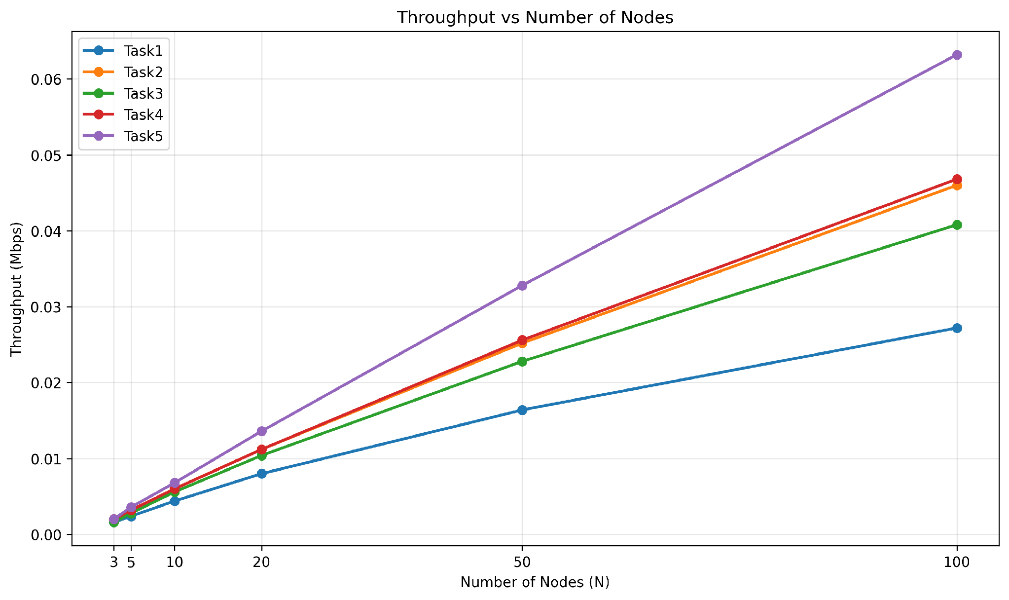
Figure 1. Throughput vs. Number of Nodes (all tasks)
The measured throughput increases with the number of wireless stations for all five backoff strategies. At N = 100, the recorded throughput ranges from 0.0272 Mbps for Task 1 to 0.0632 Mbps for Task 5. The differences between the curves reflect the different transmission and channel-access behavior observed under increasing network contention.
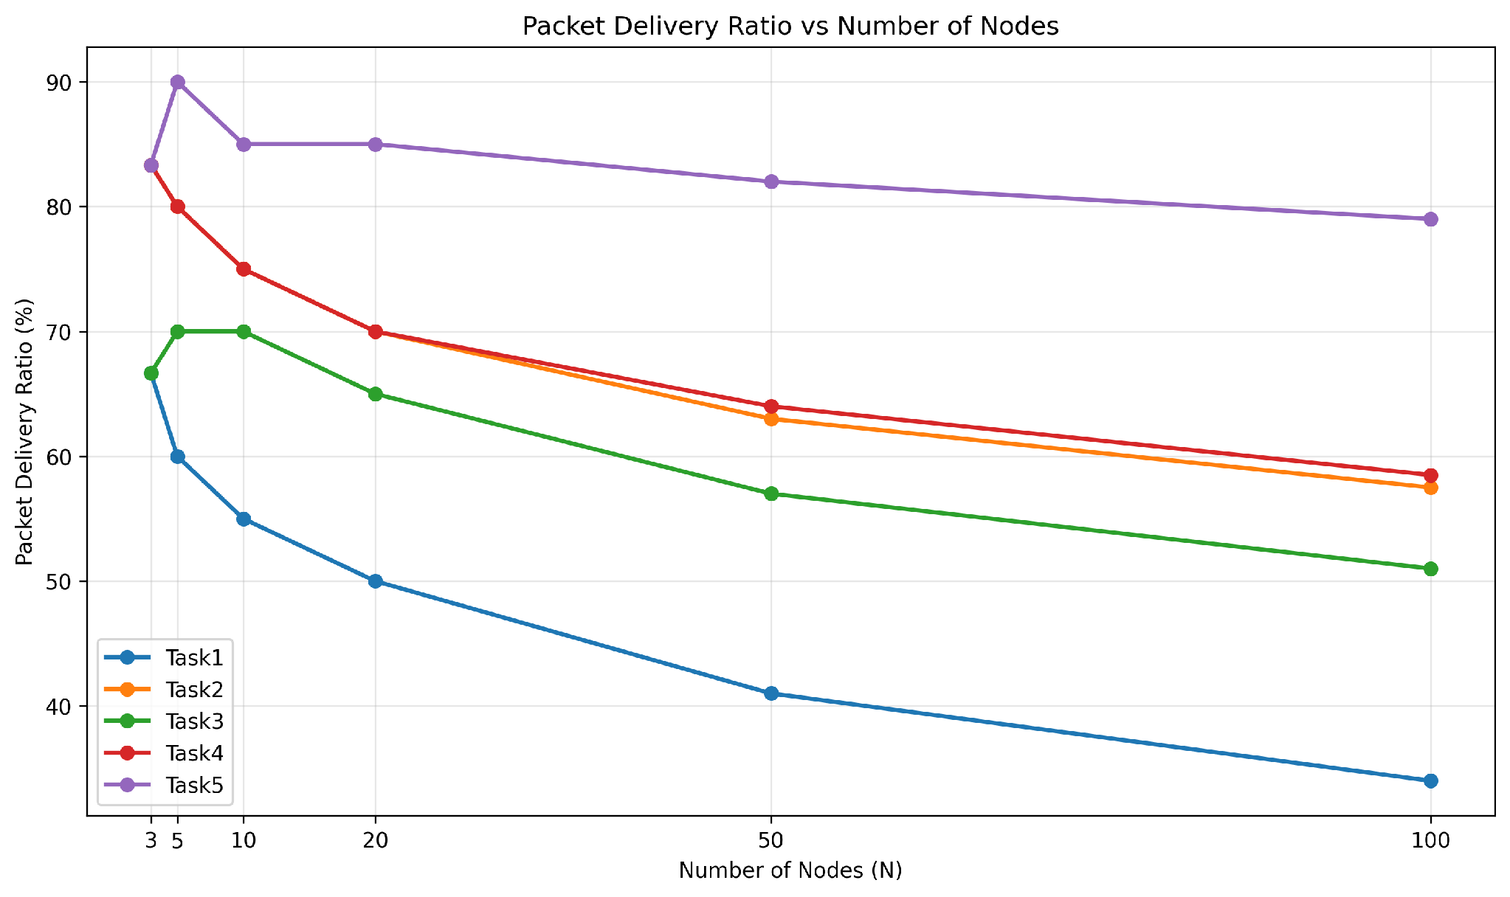
Figure 2. Packet Delivery Ratio vs. Number of Nodes
PDR generally decreases as the number of wireless stations increases for Tasks 1–4. Task 1 decreases from 66.67% at N = 3 to 34.00% at N = 100. Task 2 decreases from 83.33% to 57.50%, Task 3 from 66.67% to 51.00%, and Task 4 from 83.33% to 58.50%.
Task 5 changes from 83.33% at N = 3 to 79.00% at N = 100. Its PDR values are not strictly monotonic across the intermediate node counts.

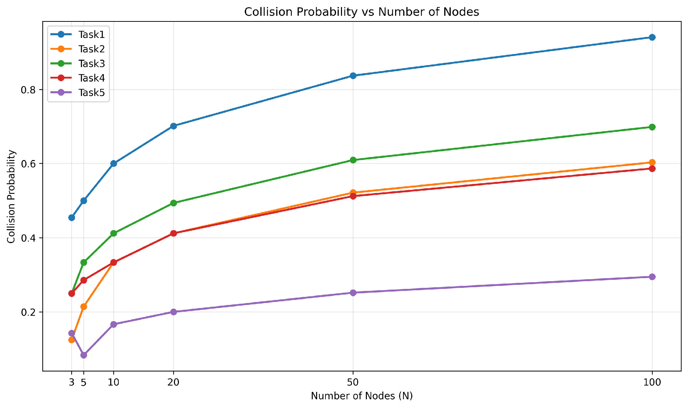
Figure 3. Collision Probability vs. Number of Nodes
The recorded collision probability increases with the number of wireless stations for all five strategies. At N = 100, the collision probabilities are 0.9408 for Task 1, 0.6032 for Task 2, 0.6988 for Task 3, 0.5868 for Task 4, and 0.2947 for Task 5.
Tasks 2 and 4 have the same collision probability at N = 10 and N = 20, with values of 0.3333 and 0.4118, respectively. At the larger node counts, their recorded collision probabilities differ.

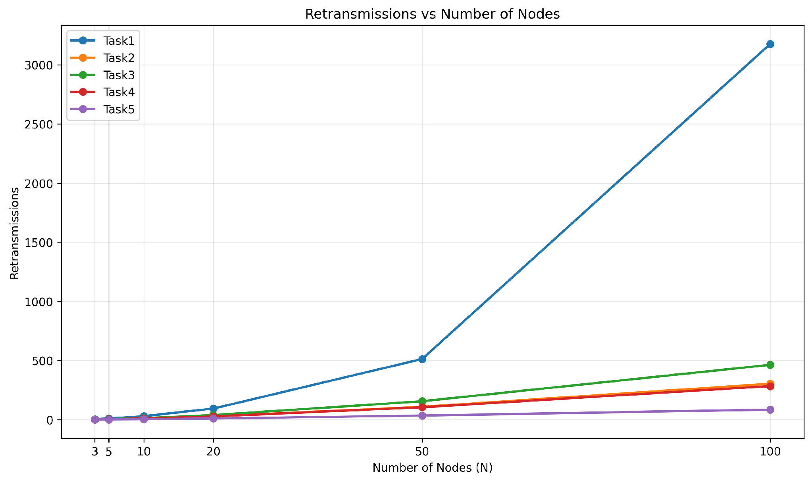
Figure 4. Retransmissions vs. Number of Nodes
The recorded retransmission count increases as the number of wireless stations increases for all five strategies. At N = 100, Task 1 records 3177 retransmissions, Task 2 records 304, Task 3 records 464, Task 4 records 284, and Task 5 records 85.
The magnitude of the increase differs substantially between the five backoff implementations as the number of contending stations grows.

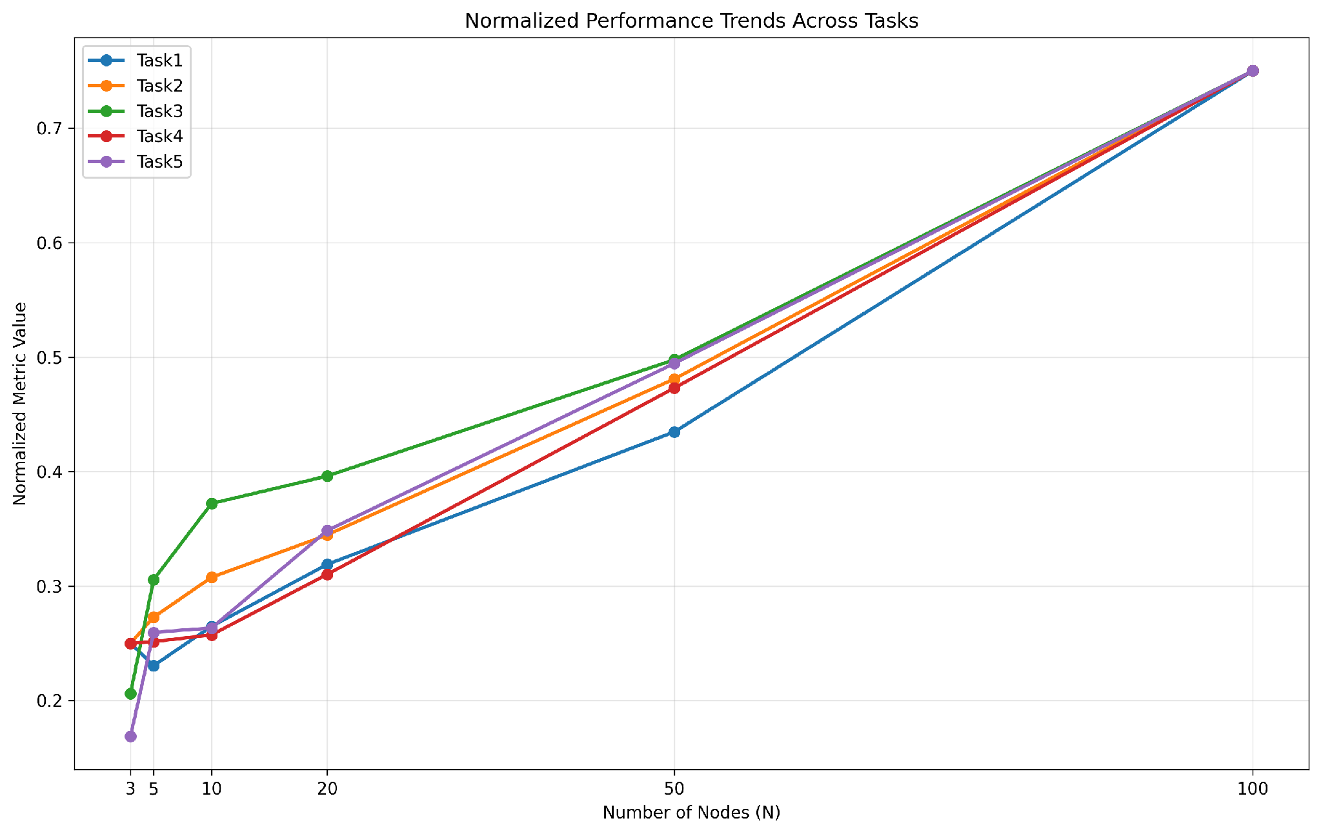
Figure 5. Normalized Performance Trends Across Tasks
The normalized plot provides a common-scale visualization of the measured trends across the experimental node densities. Each metric is normalized using its observed range before being combined for visualization.
Because throughput, PDR, collision probability, and retransmission count have different units and interpretations, the normalized plot should be treated as a visualization of the measured trends rather than as a single overall performance measure or ranking of the algorithms.

7. Comparison of Algorithms
Table 8 follows the layout of the laboratory comparison table and presents the measured results at two network sizes: a moderate network size of N = 10 and a high network size of N = 100.
The comparison uses the four metrics obtained from the OMNeT++/INET simulation results: collision probability, throughput, PDR, and retransmission count. Presenting both node densities allows the measured behavior of the five backoff implementations to be examined under different levels of network contention.
Table 8a. Comparison of MAC backoff algorithms at N = 10
Algorithm | Collision (P_{collision}) | Throughput (Mbps) | PDR (%) | Retransmission Count
Task 1 | 0.6000 | 0.0044 | 55.00 | 30
Task 2 | 0.3333 | 0.0060 | 75.00 | 10
Task 3 | 0.4118 | 0.0056 | 70.00 | 14
Task 4 | 0.3333 | 0.0060 | 75.00 | 10
Task 5 | 0.1667 | 0.0068 | 85.00 | 4

Table 8b. Comparison of MAC backoff algorithms at N = 100
Algorithm | Collision (P_{collision}) | Throughput (Mbps) | PDR (%) | Retransmission Count
Task 1 | 0.9408 | 0.0272 | 34.00 | 3177
Task 2 | 0.6032 | 0.0460 | 57.50 | 304
Task 3 | 0.6988 | 0.0408 | 51.00 | 464
Task 4 | 0.5868 | 0.0468 | 58.50 | 284
Task 5 | 0.2947 | 0.0632 | 79.00 | 85

At N = 100, the five strategies show different measured values across all four metrics. Collision probability ranges from 0.2947 to 0.9408, throughput ranges from 0.0272 Mbps to 0.0632 Mbps, PDR ranges from 34.00% to 79.00%, and the recorded retransmission count ranges from 85 to 3177.
At N = 10, Tasks 2 and 4 have identical recorded values for all four reported metrics: collision probability of 0.3333, throughput of 0.0060 Mbps, PDR of 75.00%, and 10 retransmissions. Task 3 records 0.4118 collision probability, 0.0056 Mbps throughput, 70.00% PDR, and 14 retransmissions.
The differences become more pronounced at N = 100. Tasks 2 and 4 record collision probabilities of 0.6032 and 0.5868, respectively, with corresponding throughput values of 0.0460 Mbps and 0.0468 Mbps. Their PDR values are 57.50% and 58.50%, while their recorded retransmission counts are 304 and 284.
The comparison shows that increasing the number of contending stations changes the measured behavior of all five backoff implementations. The magnitude and direction of the changes differ across throughput, PDR, collision probability, and retransmission count.

8. Discussion
The experimental results show that the measured behavior of the five MAC-layer backoff strategies changes as the number of contending wireless stations increases. The main differences are observed in collision probability, PDR, throughput, and retransmission count.
- Effect of contention among stations.
As the number of wireless stations increases, collision probability and retransmission count increase across all five strategies. For example, Task 1 increases from a collision probability of 0.4545 at N = 3 to 0.9408 at N = 100, while its recorded retransmission count increases from 5 to 3177. The other strategies also show increases in these two metrics, although the magnitude of the change differs between implementations.
- Throughput behavior.
The measured throughput increases with the number of wireless stations for all five strategies. At N = 100, the recorded throughput values are 0.0272 Mbps for Task 1, 0.0460 Mbps for Task 2, 0.0408 Mbps for Task 3, 0.0468 Mbps for Task 4, and 0.0632 Mbps for Task 5. These measurements should be interpreted together with PDR and retransmission behavior rather than as an isolated indication of MAC efficiency.
- Behavior of the deterministic backoff strategy.
Task 2 assigns deterministic initial backoff values based on the station index. Its measured PDR decreases from 83.33% at N = 3 to 57.50% at N = 100, while collision probability increases from 0.1250 to 0.6032. The implementation therefore exhibits increasing collision activity as the number of contending stations grows.
- Persistent random backoff behavior.
Task 3 retains a random base backoff for each station. Its collision probability increases from 0.2500 at N = 3 to 0.6988 at N = 100, and its retransmission count increases from 2 to 464. PDR decreases from 66.67% to 51.00% over the same range.
- Deterministic backoff with random recovery.
Task 4 combines a deterministic value following successful transmission with random recovery after a collision. Its collision probability increases from 0.2500 at N = 3 to 0.5868 at N = 100, while the retransmission count increases from 2 to 284. At N = 10, Tasks 2 and 4 have identical recorded values for all four reported metrics. At N = 100, their measured values differ.
- Adaptive contention-window behavior.
Task 5 changes the contention window according to the observed collision behavior. Across the experimental node densities, its collision probability increases from 0.1429 at N = 3 to 0.2947 at N = 100, while its recorded retransmission count increases from 1 to 85. Its PDR changes from 83.33% to 79.00%, and its throughput increases from 0.0020 Mbps to 0.0632 Mbps.
- Effect of small sample sizes.
Each station generates two packets during the 2 s simulation period. Consequently, the total number of generated packets is relatively small for N = 3 and N = 5. This discrete packet count can produce visible changes in PDR and other packet-based measurements between individual configurations. The results at these node densities should therefore be interpreted in the context of the limited number of generated packets.
- Overall observation.
The experiments demonstrate that changing the MAC-layer backoff mechanism produces measurable differences in channel-access behavior under increasing contention. The five strategies exhibit different changes in collision probability, PDR, throughput, and retransmission count. These results provide an empirical comparison of the implemented backoff mechanisms under the specific topology, traffic pattern, PHY configuration, and simulation duration used in this study.

9. Answers to Task-Specific Questions

9.1 Task 1: Common Backoff with Collision-Based Doubling
- Why do simultaneous nodes collide?
When multiple stations use the same backoff value and their transmission attempts occur at the same time, their frames can overlap and produce a collision. In the Task 1 implementation, stations use a common initial backoff behavior, which can result in synchronized transmission attempts.
- What is the effect of collision-based doubling?
After a collision, the contention window is increased according to the configured collision-response mechanism. The purpose of this increase is to spread subsequent transmission attempts over a larger contention range. The measured collision probability nevertheless increases from 0.4545 at N = 3 to 0.9408 at N = 100.
- How does the number of nodes affect throughput?
Throughput increases from 0.0016 Mbps at N = 3 to 0.0272 Mbps at N = 100. During the same range, PDR decreases from 66.67% to 34.00%. Thus, the increase in offered traffic with additional stations is accompanied by a reduction in the proportion of generated packets successfully delivered.
- What happens at large N?
At N = 100, Task 1 records a collision probability of 0.9408, a PDR of 34.00%, and 3177 recorded retransmissions. These measurements indicate substantially increased collision and retransmission activity at the highest evaluated node density.
- How does Task 1 compare with standard 802.11?
Standard IEEE 802.11 DCF uses randomized contention-window backoff. Task 1 uses the common backoff behavior specified for this experiment. The current dataset does not contain a separate standard-802.11 baseline run, so a quantitative comparison with the standard configuration cannot be established from the available experiments.

9.2 Task 2: Incremental Deterministic Initial Backoff
- Does deterministic assignment reduce collisions?
The measured collision probability for Task 2 is lower than that of Task 1 at all six evaluated node densities. At N = 3, the values are 0.1250 and 0.4545, respectively. At N = 100, they are 0.6032 and 0.9408. The results therefore show different collision behavior between the two implementations.
- How does it affect throughput?
At N = 100, Task 2 records 0.0460 Mbps throughput, 57.50% PDR, and 304 retransmissions. At N = 3, the corresponding values are 0.0020 Mbps, 83.33%, and 2 retransmissions.
- Can deterministic assignment introduce differences between stations?
The implementation assigns different initial backoff values according to the station index. This means stations do not start from the same deterministic value. However, per-station throughput and delay were not recorded in the current dataset, so the magnitude of any station-level fairness difference cannot be quantified from these results.
- What happens as N increases?
Collision probability increases from 0.1250 at N = 3 to 0.6032 at N = 100. PDR decreases from 83.33% to 57.50%, while the retransmission count increases from 2 to 304.
- What happens when the number of nodes changes dynamically?
The deterministic assignment depends on station indexing. A change in the participating station set would therefore require the corresponding index assignment to remain consistent with the implementation. Dynamic-node behavior was not separately evaluated in the current simulation dataset.

9.3 Task 3: Persistent Random Backoff
- What is the effect on collisions?
Task 3 uses a persistent random base backoff for each station. The measured collision probability increases from 0.2500 at N = 3 to 0.6988 at N = 100. PDR decreases from 66.67% to 51.00%, while retransmissions increase from 2 to 464.
- What happens when two stations use the same backoff value?
Stations with overlapping transmission opportunities can experience repeated collisions depending on their subsequent backoff behavior. The simulation results show increasing collision and retransmission activity as the number of contending stations grows. The current dataset does not separately record the number of stations sharing each persistent value, so the frequency of this specific event cannot be quantified directly.
- What is the effect of the contention-window size?
A larger contention window provides a larger range from which backoff values can be selected. However, the current experiment does not provide a separate CW-sweep dataset for Task 3. Therefore, the effect of changing CW independently cannot be quantified from the reported results.
- What can be concluded about fairness?
The current experiment does not record per-station throughput or another fairness metric. Therefore, fairness of the persistent random strategy cannot be quantitatively evaluated from this dataset.
- How does Task 3 compare with Tasks 1 and 2?
At N = 100, Task 3 records a collision probability of 0.6988, compared with 0.9408 for Task 1 and 0.6032 for Task 2. Its throughput is 0.0408 Mbps, PDR is 51.00%, and retransmission count is 464.

9.4 Task 4: Deterministic Backoff with Collision Randomization
- How does deterministic backoff affect channel access?
Task 4 retains a deterministic backoff value following successful transmission and uses random recovery after a collision. This produces a different sequence of contention behavior from the persistent random strategy used in Task 3.
- What happens when two stations have the same deterministic backoff?
If multiple stations reach transmission at the same opportunity, a collision can occur. The Task 4 implementation uses random recovery following a collision, allowing subsequent transmission opportunities to differ. The available measurements show the resulting aggregate collision and retransmission behavior but do not separately quantify individual collision-recovery events.
- What is the effect of collision randomization?
At N = 100, Task 4 records a collision probability of 0.5868 and 284 retransmissions. Task 3 records 0.6988 and 464, respectively. These measurements show different aggregate collision and retransmission behavior between the two implementations.
- How does channel performance change with N?
Task 4 throughput increases from 0.0020 Mbps at N = 3 to 0.0468 Mbps at N = 100. PDR changes from 83.33% to 58.50%, while collision probability increases from 0.2500 to 0.5868 and retransmissions increase from 2 to 284.
- Can fairness be determined from these experiments?
A quantitative fairness conclusion cannot be made because per-station throughput and other per-node fairness statistics were not recorded. A separate experiment containing per-station measurements would be required to calculate a metric such as Jain's fairness index.

9.5 Task 5: Adaptive Contention Window
The laboratory specification does not list separate task-specific questions for Task 5. The following observations summarize the measured behavior of the adaptive contention-window implementation.
- What behavior is observed across the evaluated node densities?
Task 5 records collision probabilities of 0.1429 at N = 3 and 0.2947 at N = 100. Over the same range, throughput increases from 0.0020 Mbps to 0.0632 Mbps, PDR changes from 83.33% to 79.00%, and recorded retransmissions increase from 1 to 85.
- How does collision probability change with network size?
Collision probability increases as the number of wireless stations increases. The increase from N = 3 to N = 100 is from 0.1429 to 0.2947. The adaptive contention-window mechanism is intended to respond to observed collision activity, but the current dataset does not include a separate average-CW trace that would allow the relationship between CW changes and collision probability to be quantified directly.
- What additional Task 5 experiments are required?
The current dataset does not contain the load-dependent experiments specified for Task 5. Additional simulations are required for the low-, medium-, high-, bursty-, and saturated-load conditions, together with average contention-window and delay measurements.
- What can be concluded from the current Task 5 results?
The current results show the aggregate throughput, PDR, collision probability, and retransmission behavior for the six evaluated node densities. They do not provide sufficient measurements to characterize the adaptive contention-window behavior under different traffic loads or to evaluate fairness and delay.
- What additional statistics would strengthen the analysis?
Recording the contention-window value over time, average CW per node, packet delay, per-node throughput, dropped packets, and results from multiple independent simulation runs would provide additional evidence for analyzing the adaptive behavior and variability of Task 5.

10. Conclusion
This report evaluated five MAC-layer backoff strategies for an IEEE 802.11 DCF wireless network with wireless-station counts ranging from N = 3 to N = 100. The experiments used a common topology, traffic pattern, PHY configuration, and simulation duration, while varying the MAC-layer backoff behavior.
The OMNeT++/INET simulation results show that increasing the number of contending stations is associated with increased collision probability and retransmission activity across the evaluated strategies. The magnitude of these changes differs between the five implementations.
- Task 1: Collision probability increases from 0.4545 at N = 3 to 0.9408 at N = 100, while the recorded retransmission count increases from 5 to 3177. PDR decreases from 66.67% to 34.00%.
- Task 2: Collision probability increases from 0.1250 to 0.6032 as N increases from 3 to 100. Over the same range, throughput increases from 0.0020 Mbps to 0.0460 Mbps, while PDR decreases from 83.33% to 57.50% and retransmissions increase from 2 to 304.
- Task 3: Collision probability increases from 0.2500 to 0.6988, PDR decreases from 66.67% to 51.00%, and recorded retransmissions increase from 2 to 464 between N = 3 and N = 100.
- Task 4: Collision probability increases from 0.2500 to 0.5868, while throughput increases from 0.0020 Mbps to 0.0468 Mbps. PDR changes from 83.33% to 58.50%, and retransmissions increase from 2 to 284.
- Task 5: Collision probability increases from 0.1429 to 0.2947, while throughput increases from 0.0020 Mbps to 0.0632 Mbps. PDR changes from 83.33% to 79.00%, and recorded retransmissions increase from 1 to 85.
Overall, the experiments demonstrate that the choice of backoff mechanism affects aggregate MAC-layer behavior as network contention increases. The differences are visible in collision probability, packet delivery ratio, throughput, and retransmission count. However, the current dataset does not include average delay, per-node fairness, average contention-window statistics, traffic-load sweeps, or multiple independent simulation runs. These measurements would be required for a more complete evaluation of delay, fairness, adaptive contention-window behavior, and statistical variability.
The conclusions presented in this report are therefore limited to the five implemented strategies, the six evaluated wireless-node densities, and the specific OMNeT++/INET simulation configuration used in the experiments.

